INTERFACE:

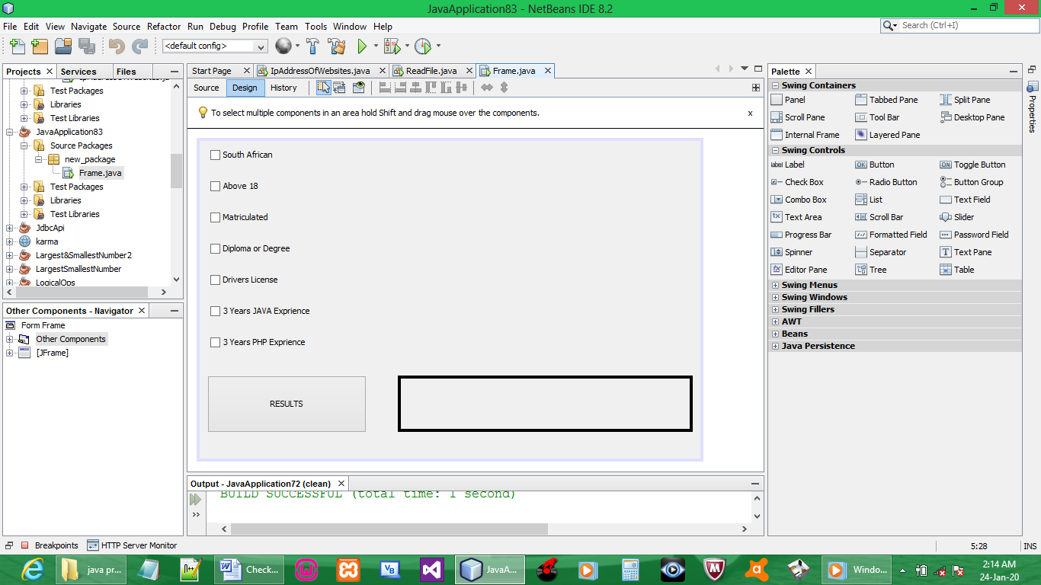

CODE:

BUTTON RESULT

private void btnResultsActionPerformed(java.awt.event.ActionEvent evt) {

try{
if (!(cbNationality.isSelected()) && ! (cbAge.isSelected()) && ! (cbMatric.isSelected()) &&
!(cbQualification.isSelected()) && ! (cbDrivers.isSelected()) && ! (cbJava.isSelected()) &&
!(cbPhp.isSelected()) ){
lblOutput.setText("Minimum of 5 checkboxes must be selected to qualify for an interview");
}
if (cbNationality.isSelected() && cbAge.isSelected() && cbMatric.isSelected() &&
cbQualification.isSelected() && cbDrivers.isSelected() && cbJava.isSelected() &&
cbPhp.isSelected()){
lblOutput.setText(" You Checked 7/7 boxes. Outstanding for an interview");
}

else if (cbNationality.isSelected() && cbAge.isSelected() && cbMatric.isSelected() &&
cbQualification.isSelected() && cbDrivers.isSelected() && cbJava.isSelected() ^
cbPhp.isSelected()){
lblOutput.setText(" You Checked 6/7 boxes. Meritorious for an interview");
}
else if (cbNationality.isSelected() && cbAge.isSelected() && cbMatric.isSelected() &&
cbQualification.isSelected() && cbDrivers.isSelected() ^ cbJava.isSelected() ^
cbPhp.isSelected()){
lblOutput.setText(" You Checked 5/7 boxes.Adequate for an interview");
}
else if (cbNationality.isSelected() && cbAge.isSelected() && cbMatric.isSelected() &&
cbQualification.isSelected() ^ cbDrivers.isSelected() ^ cbJava.isSelected() ^
cbPhp.isSelected()){
lblOutput.setText(" You Checked 4/7 boxes. Not Achieved for an interview, Minimum is 5/7 boxes");
}
else if (cbNationality.isSelected() && cbAge.isSelected() & cbMatric.isSelected() ^
cbQualification.isSelected() ^ cbDrivers.isSelected() ^ cbJava.isSelected() ^
cbPhp.isSelected()){
lblOutput.setText(" You Checked 3/7 boxes. Failed for an interview , Minimum is 5/7 boxes");
}
else if (cbNationality.isSelected() & cbAge.isSelected() ^ cbMatric.isSelected() ^
cbQualification.isSelected() ^ cbDrivers.isSelected() ^ cbJava.isSelected() ^
cbPhp.isSelected()){
lblOutput.setText(" You Checked 2/7 boxes. Failed to quality to qualify for an interview, Minimum is 5/7 boxes ");
}

else if (cbNationality.isSelected() ^ cbAge.isSelected() ^ cbMatric.isSelected() ^
cbQualification.isSelected() ^ cbDrivers.isSelected() ^ cbJava.isSelected() ^
cbPhp.isSelected()){
lblOutput.setText(" You Checked 1/7 boxes. Dismally failed to qualify for an interview , Minimum is 5/7 boxes");
}
}

catch (NumberFormatException e) {
lblOutput.setText("Must check atleast 5 boxes to qualify");
}
}

OUTPUT:

7/7 checkboxes
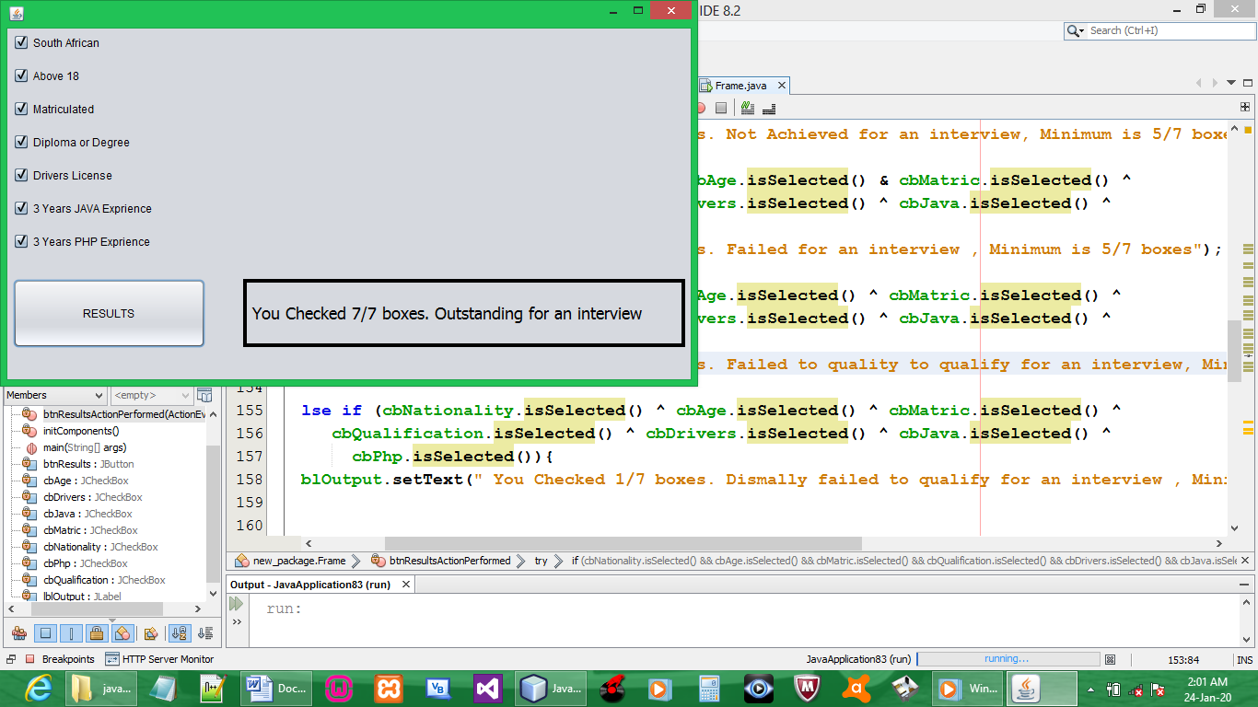

6/7 checkboxes
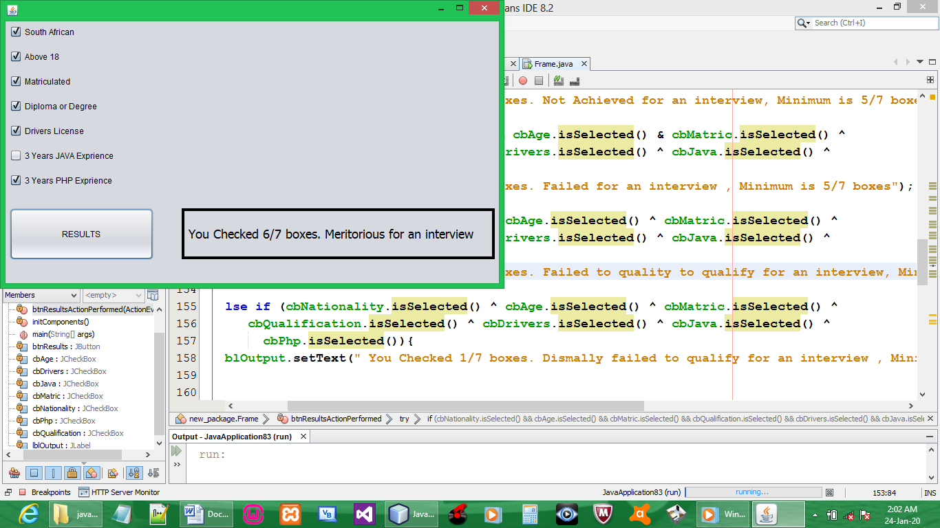

5/7 checkboxes
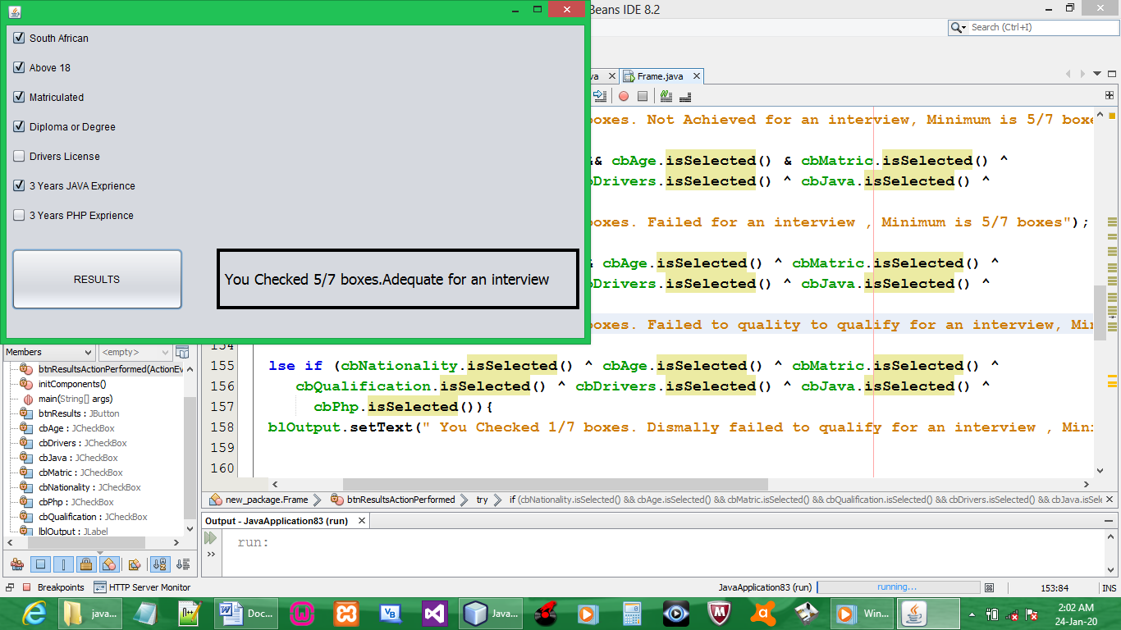

4/7 checkboxes
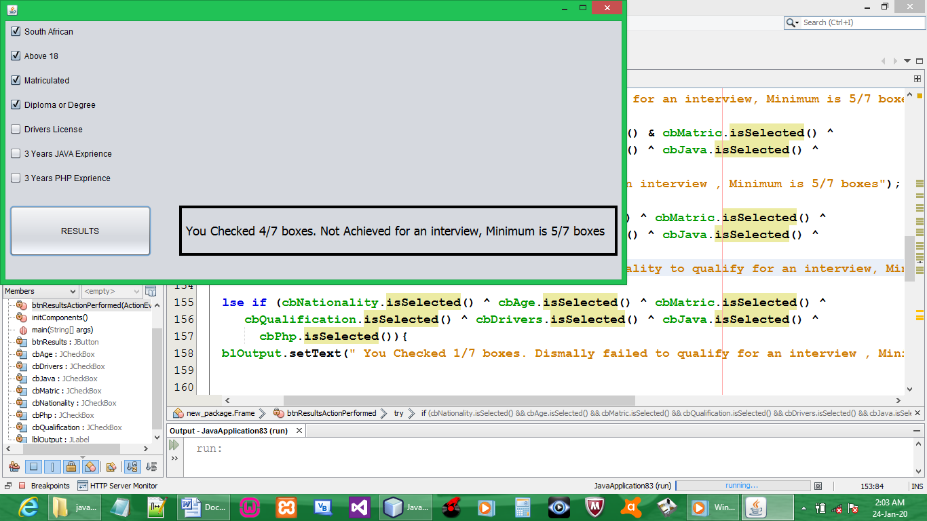

3/7 checkboxes
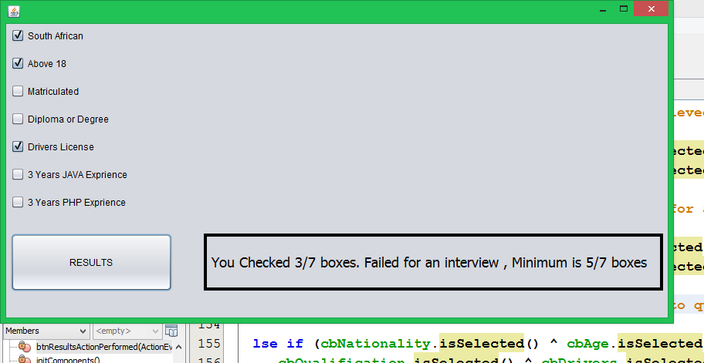

2/7 checkboxes
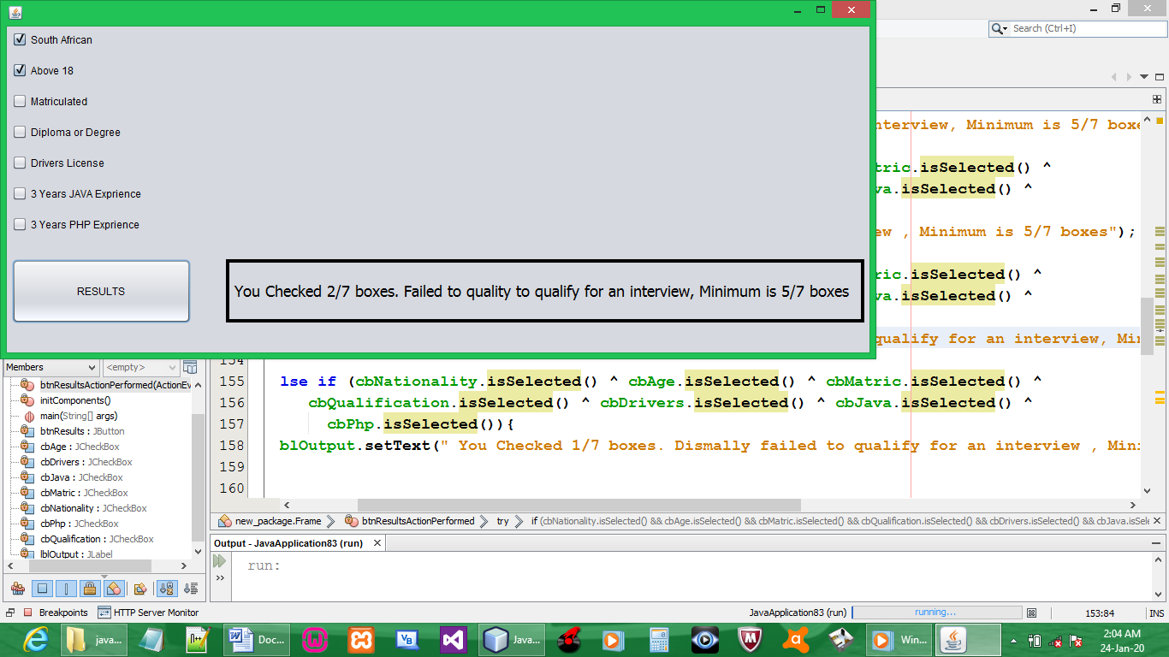

1/7 checkboxes
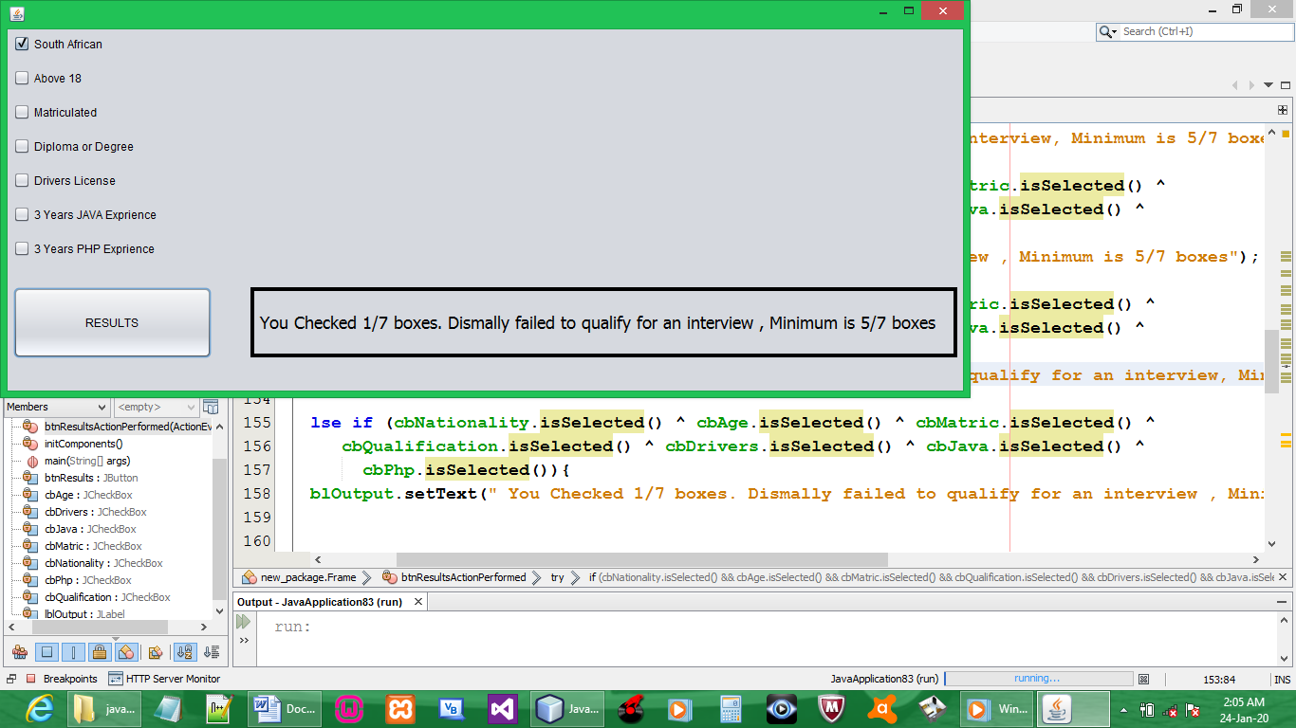

0/7 checkboxes
